
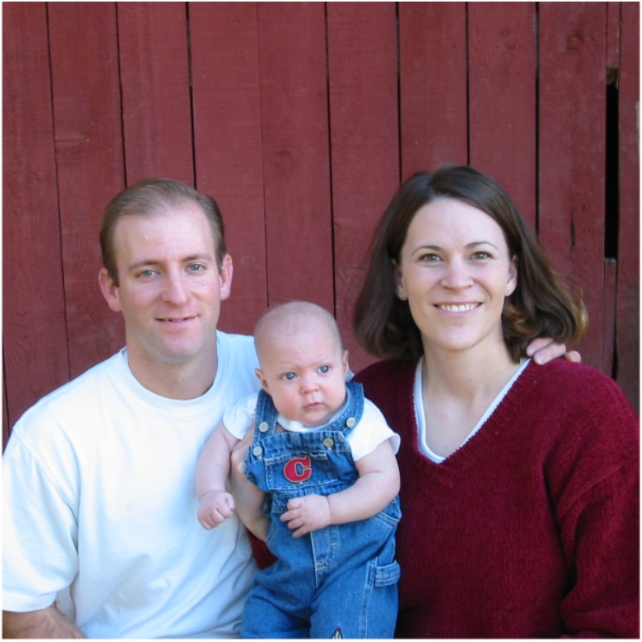
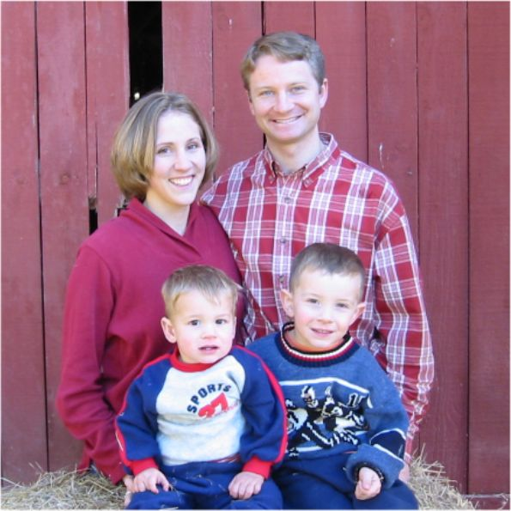

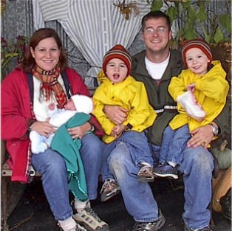
Karl and Kristina Shurts  (Ben - 10, Michaela - 8, Kiana - 8, Dallin - 6, Kandra - 3 1/2)  1915 SE 70th Avenue, Hillsboro, OR 97123 | Tel: 503-848-0805  Email: knshurts@yahoo.com
The Shurts Family is getting ready to realize their dream of living in the country (Germany style). They are hoping to start building their farm house next March with Nina’s original design. Karl is still working at Intel and Nina is still involved with her campaign to keep “adult” businesses out of their neighborhood (see www.siege-oregon.org). It was fun to have their family come to Utah and for “Opa” (Kent) to take everyone (except Kandra) up in the powerchute. They made a stop at Yellowstone on the way home and are looking forward to Christmas in Oregon.

Kevin Price  1993 North 700 West  Provo, UT 84604 | Tel: 801-375-5967  Email: krp25@email.byu.edu
Kevin is at BYU majoring in Mechanical Engineering. He spent the summer in Oregon living part of the time with Kristina and part of the time with Krey. He had a great job doing excavating and driving earth moving equipment. He just finished his final marching band season as section leader for the trombones. He plans to tour China with the BYU Wind symphony in the Spring. So he has a lot going on with a tough major and trying to keep up his music. Of course, he joined an acapella singing group so life wouldn’t be too boring. Keena is still trying to figure out whether it was a good idea for Kent to let Kevin fly solo in the powerchute.

Krey and Lindy Price  (Jaedin - 4, Cambren - 2 ½, Addisen - 3 months)  2419 Lewellyn, Troutdale, OR 97060 | Tel: 503-661-1013  Email: krey@krey.org  Web: www.krey.org/prices
Krey and Lindy were thrilled to welcome their first daughter, Addisen Kaelie Marta Price into the world on September 4th. Jaedin and Cam are such loving brothers. Hi-tech Krey has given each of the kids their own internet domain! Look up www.Jaedin.com, www.cambren.com, or www.addisen.com. Krey is getting more into project management at Tetra Tech Engineering now that he is in Portland. He just wishes he could have more time for “field” work. Lindy amazes us all with her decorating skills. And we’re happy that Jaedin’s infection seems to be under control so he won’t need any more surgeries. His life is a true miracle and he’s such a sweet, sensitive child.

Neal and Kerrie Davis (Kenton - 3, Merrill - 1)  1402 University Village  Salt Lake City, UT 84108 | Tel: 801-582-3764  Email: kenton@burgoyne.com
We can’t believe that Neal is almost finished with medical school at University of Utah! He and Kerrie are looking at places for his residency which starts next year. This may mean that they’ll be far away again. Kerrie had a dream come true when she was accepted into the Orchestra on Temple Square playing Oboe and English Horn. She is so happy that she and Kamber get to play in concerts together. In September, Kerrie joined Kevin in running the “Top of Utah” marathon. Most of all, Neal and Kerrie enjoy their cute boys – Kenton with his amazing vocabulary and Merrill with his winning smile and charm.

Jared and Kamber Turner (David Kimball - 4 months)  2237 North 1000 West  Provo, UT 84604 | Tel: 801-377-6324  Email:kamberturner@hotmail.com
Kamber and Jared are in seventh heaven with the birth of their first child, David Kimball Turner, on August 6th. He was 31/2 weeks early and we had a few panicy moments at first, but he overcame everything and is thriving. Jared is in construction management at BYU and we were able to use his expertise as we built a large office out of two bedrooms in our new home. Kami is still playing French Horn in the Orchestra on Temple Square and has a lot of Christmas concerts this year (and guess who gets to babysit - ☺ ). Kamber had to give up her job at the BYU library when David was born, but she still teaches horn privately and at a local school.
The Next Generation (s)….

