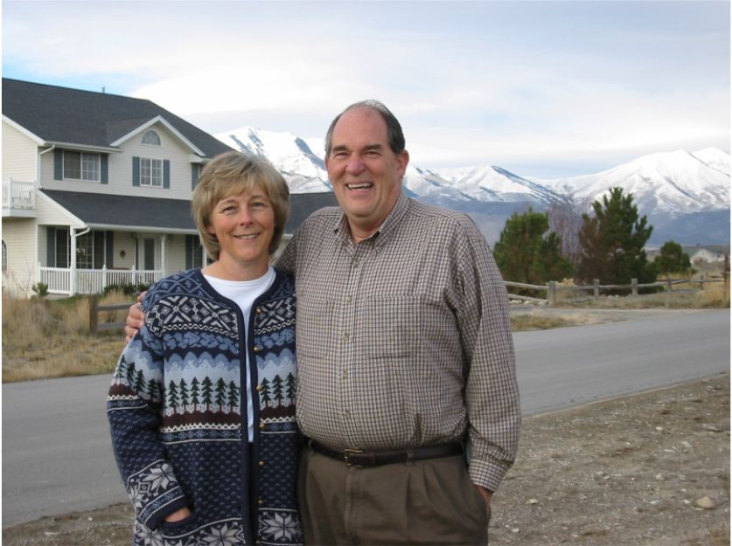
Christmas 2002
SEASON’S GREETINGS
From Kent & Keena Price

Dear Friends and Family,

The short version: New home, new job, 2 new grandchildren, some travel and pretty good health.

The long version: Well, we’re finally in a home of our own after being in an apartment for a year and a half. In June we bought a home in Eagle Mountain, Utah (about 30 miles south of Salt Lake City). We have five acres out in the sage brush - with a big gulley in the back, a view of mountains in all directions, and yes, a landing strip for Kent’s new powered parachute. It’s so nice to have our old, familiar furniture and to have space for family gatherings. We have 3 of our children here in Utah and the other 2 in Oregon. We also have 7 siblings and our mothers here, so we’re really enjoying ourselves to the hilt.

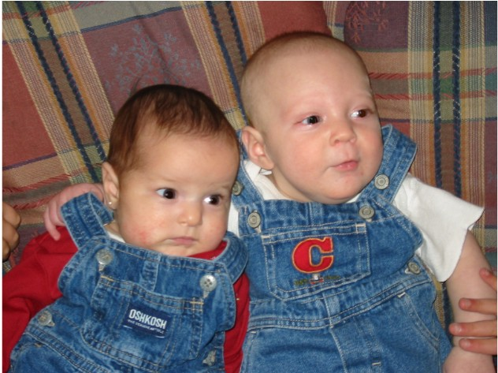
Being here in Utah, we’ve been able to babysit, go to Kamber and Kerrie’s concerts, have birthday celebrations and extended family gatherings. It’s been fun to have the Oregon families here from time to time and to take the motorhome to places like Lake Powell, the Uintah Mountains, Utah’s “Dixie” and the Valley of the Goblins. The two of us have been able to duck off to San Diego, Las Vegas, and Kent’s Kaiserslautern (Germany) High School reunion held in New Orleans. That was our first visit to Cajun Land and we really enjoyed it. Our best trip of the year was loading all of our Utah posterity in the motor home and driving to Portland to spend Thanksgiving with Kristina and Krey and their families. We were able to see our two twin granddaughters baptized and participate in the blessing of the newest grandchild.
Our two newest grandkids:
Addisen and David


Keena: For me, the best part of our Utah experience is being able to take care of grandchildren. I’ve been known to call up and say, “Don’t you need to go some place today so I can babysit?” I still work at the Draper Care Center a few days a week and really enjoy the nursing duties there. In church, Kent and I were just called to be the Stake Welfare Specialists. I’m also having fun being at “home-on-the-range.” I started riding horses with some of the neighbor ladies and appreciate the friendly people here (even if the horse threw me off last week). For my birthday, our kids surprised me with 3 live chickens (Lulu, Matilda and Henrietta), and Kent made me a chicken hutch. In October, Kristina came down from Portland for a few days so she, Kami, Kerrie and I were able to do a lot of “girly” things together – what fun!
The Girls: Kristina, Kamber, Kerrie & Keena

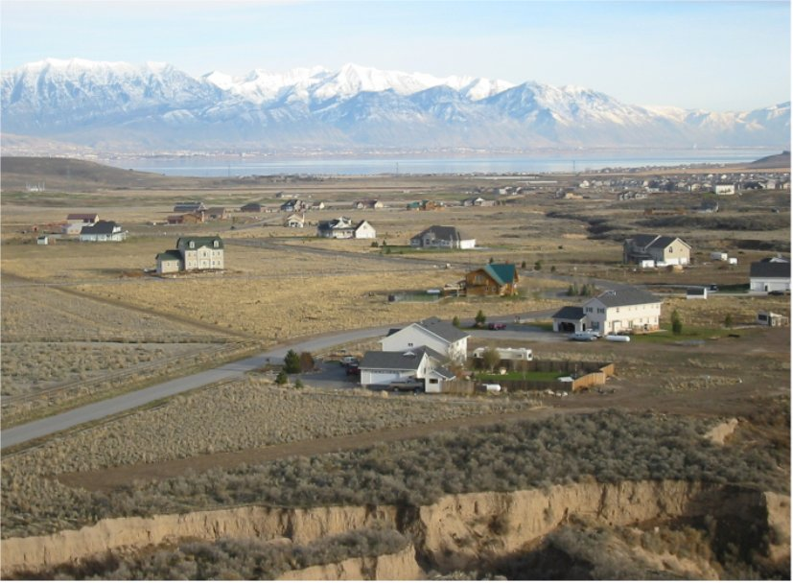
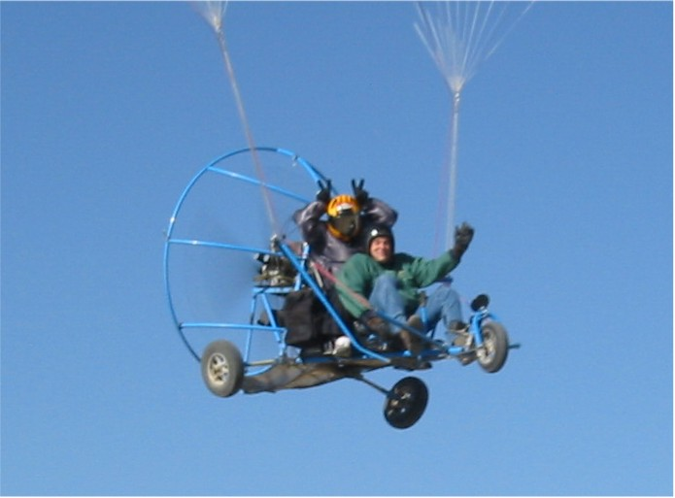
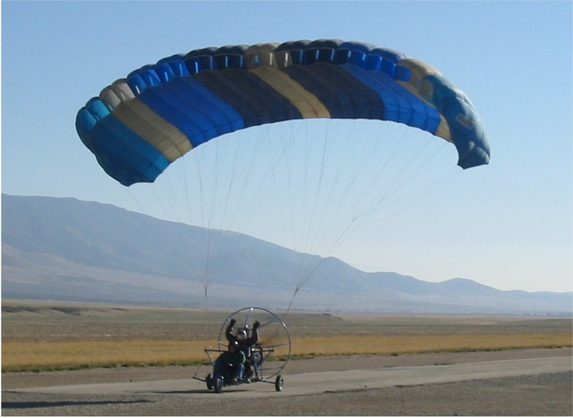
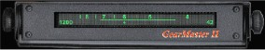

Kent: Last April, Liquitek Enterprises, for whom I had been working since we moved to Utah, ran out of funding and had to divest itself of all its subsidiaries – including the two that I had been in charge of. But, as they say, when one door closes, another opens. For several years, I have been working part time on the GearMaster, a new instrument for the trucking industry. The last major development phase was just being completed and so ever since Liquitek folded, I have been devoting full time to bringing the GearMaster to market. It has been fun, exciting and a little bit frightening. We just received an order from the country’s largest trucking fleet and we have been selling a lot of units to truck driving schools around the country – so it is starting to catch on. If you are interested, check out the website at www.gearmaster.com for more info. Besides serving in the church as Stake Welfare Specialist with Keena, I enjoy teaching the Gospel Doctrine Sunday School class. I’ve also kept up all my flying ratings over the years and have been doing some ultralight instruction in powered parachutes.
Kent’s favorite view of our house -
just coming in for a landing with Utah Lake and Provo Peak in the background.
See our website (below) for more pictures and explanation.


So, once again, it has been a good year for the Prices. Except for a few signs of encroaching age, we feel healthy, happy and very blessed. We treasure our relationships with friends and family and hope to keep up with you over the years. Please give us a call, drop us a line, or come for a visit.
We send, as always, our love and best wishes.

2344 Valley Drive Email: khprice@aol.com Phone: 801-768-2608
Eagle Mountain, UT 84043 Website: www.kprice.com Cell: 801-554-0015

